AWS Task-2
Task Description:

Set up a VPC with an Internet gateway, create a public subnet with 256 IP addresses, a private subnet with 256 IP addresses, make a route table connecting the Internet gateway and the subnets, and launch a Linux EC2 instance by using the above VPC and public subnet.

VPC:
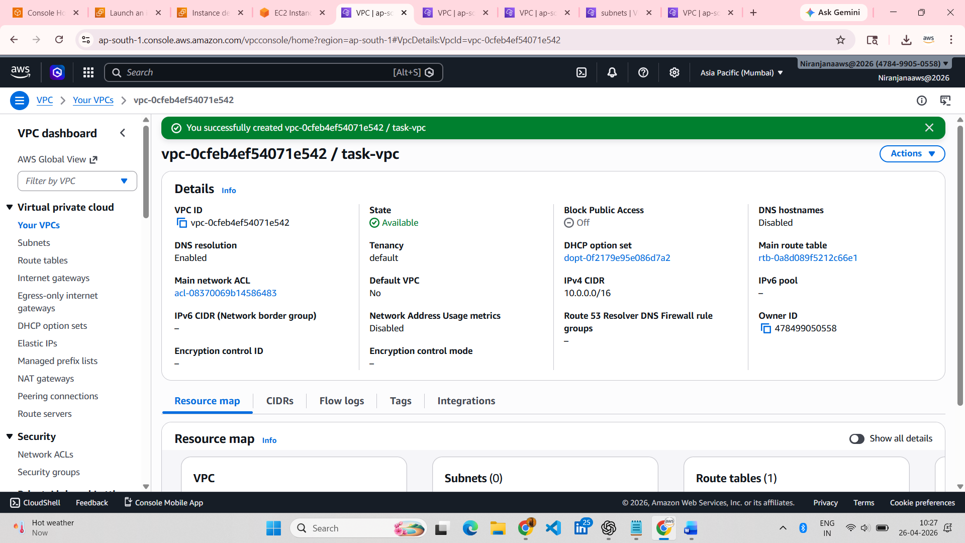
Internet Gateway:
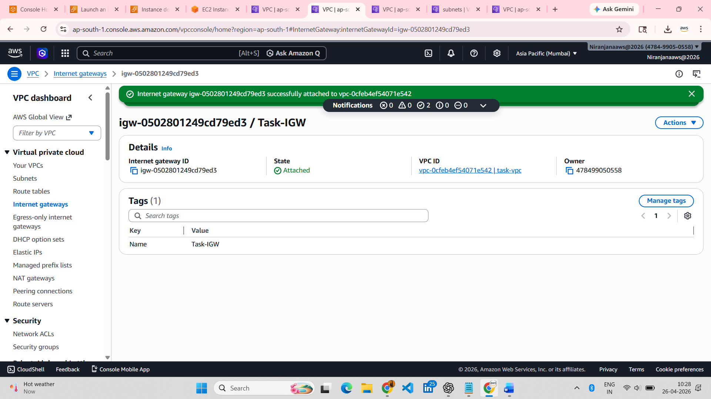
Public Subnet:
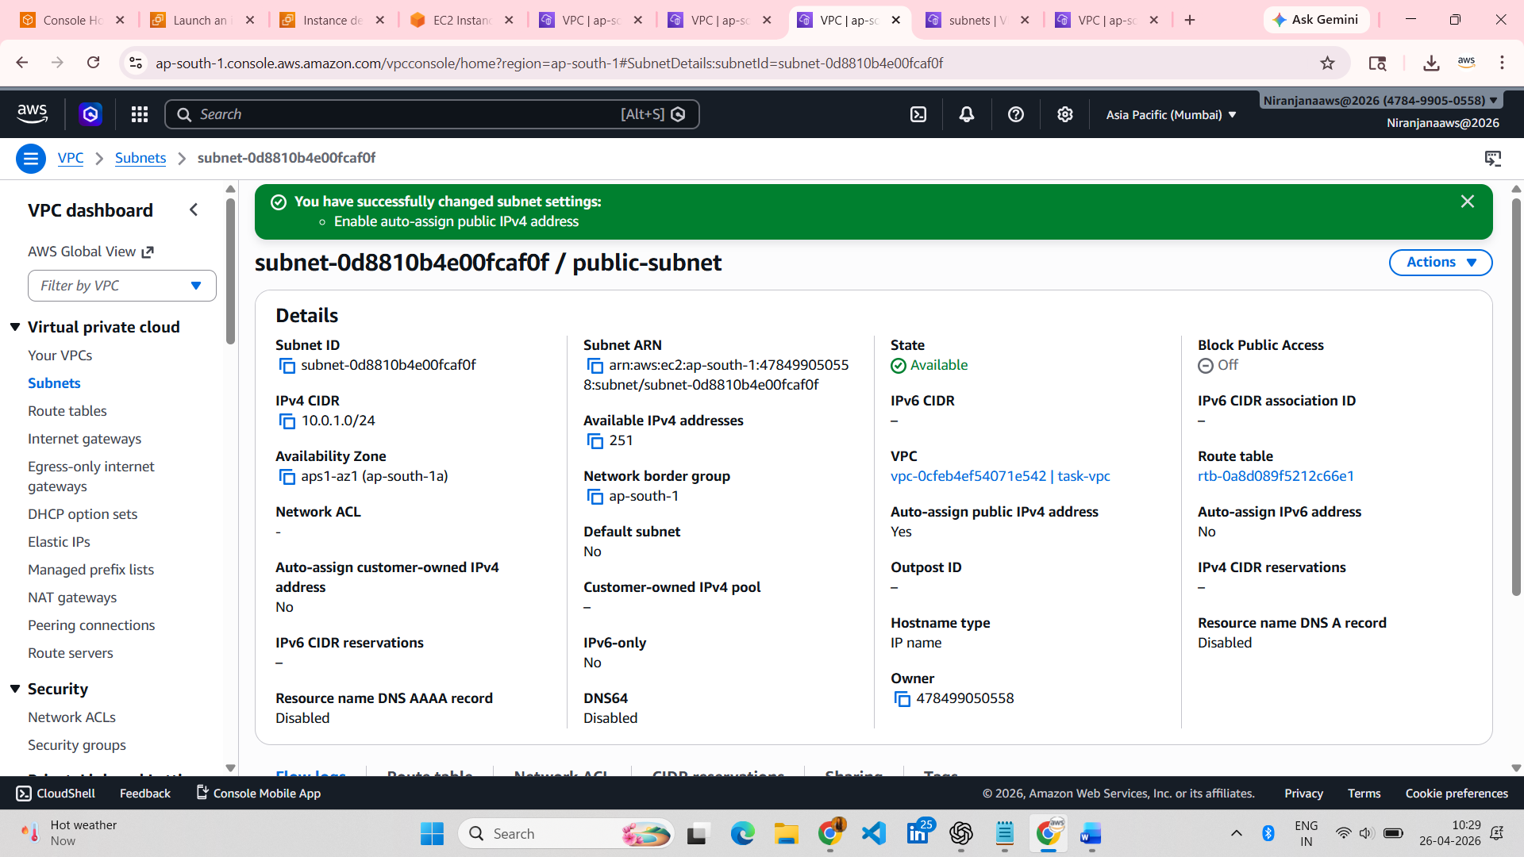

Private Subnet:

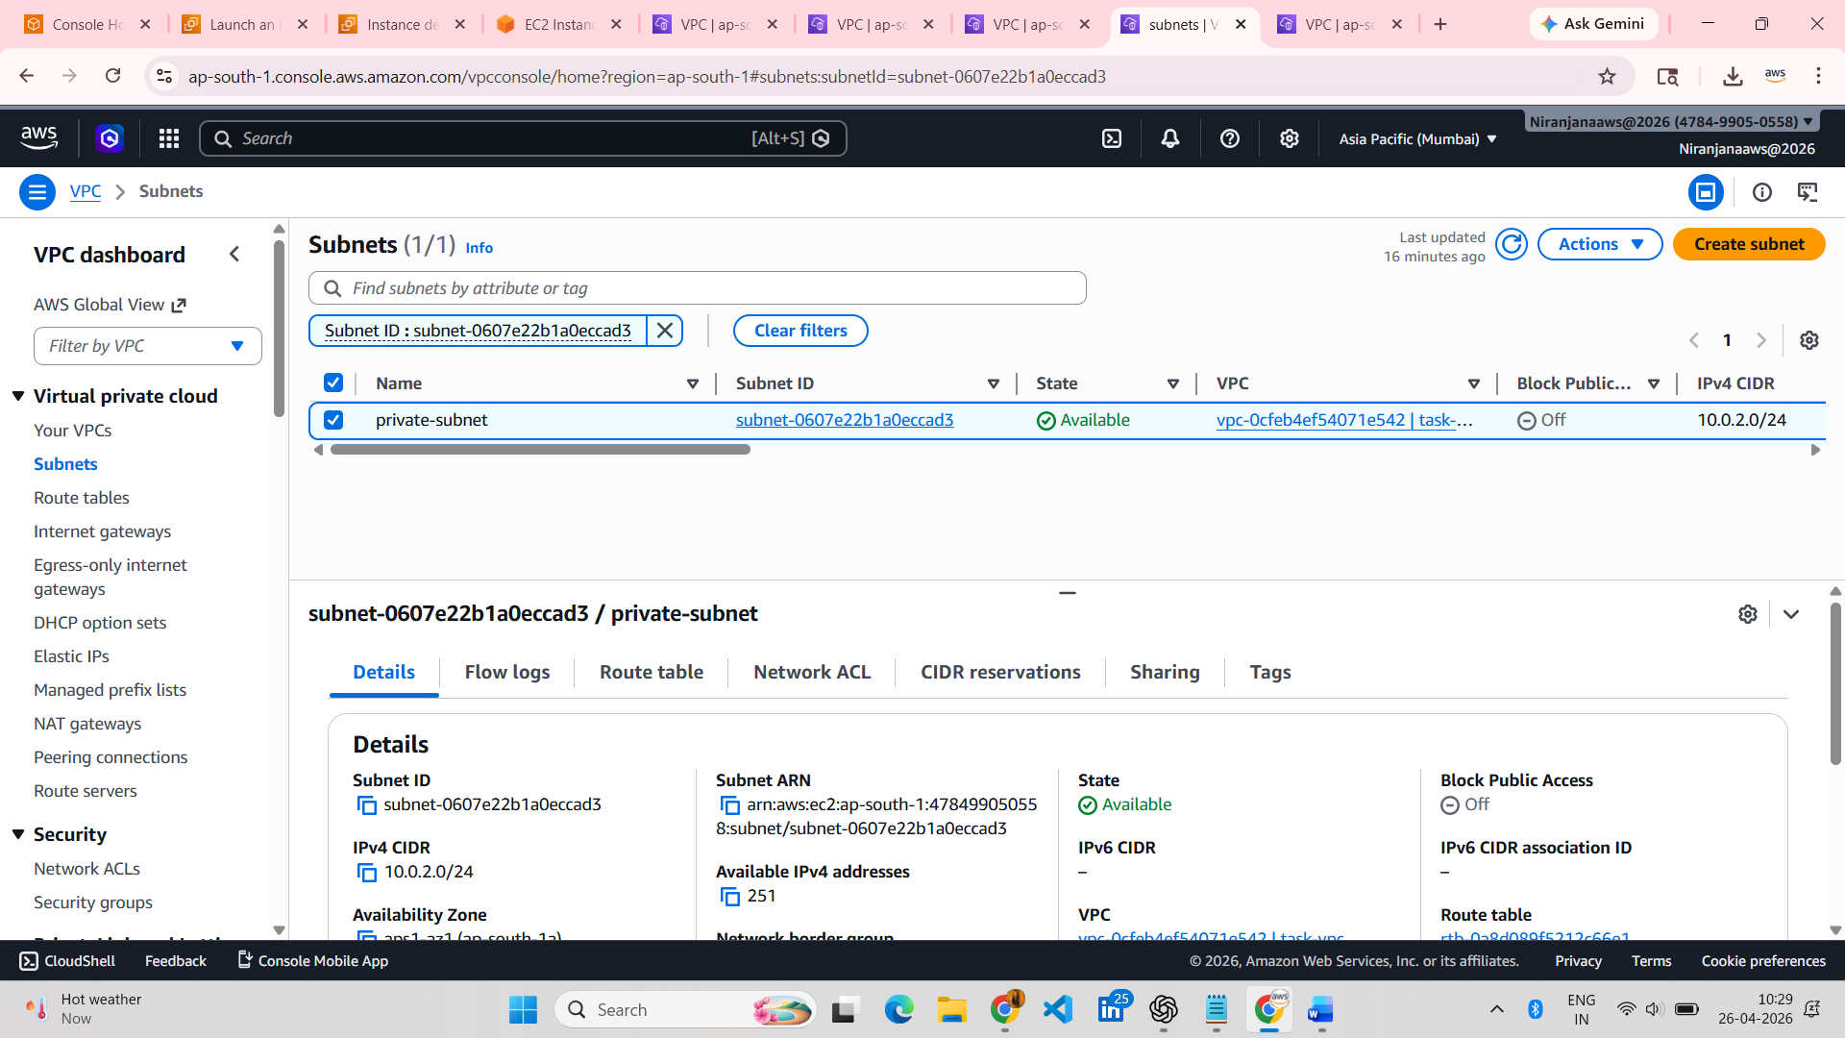

Route Tables:

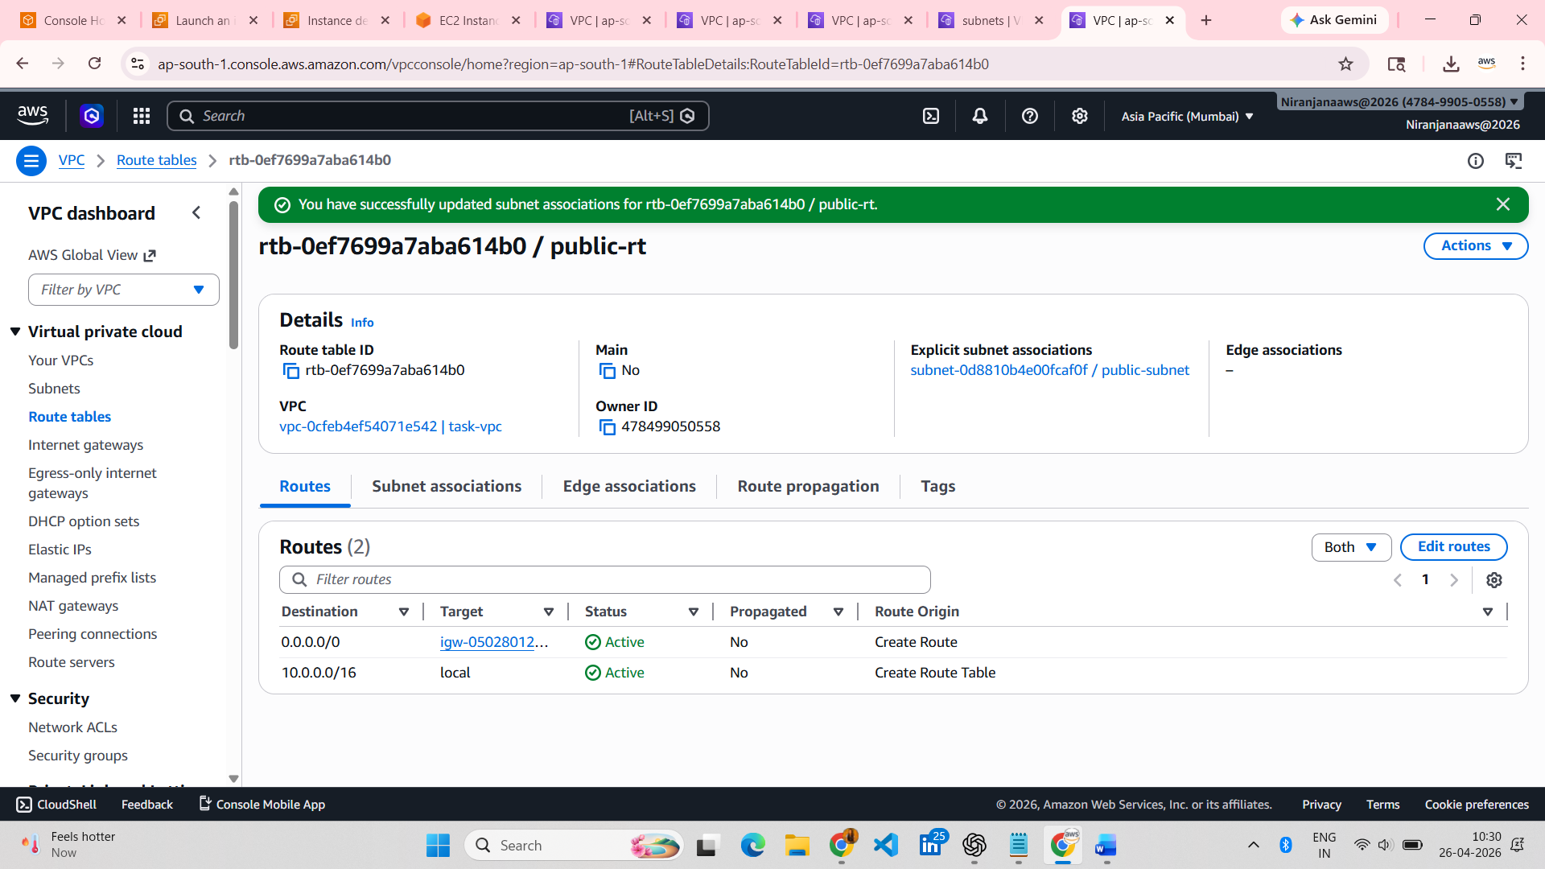

Linux EC2 Instance:
